In order to add a serial port manually in Windows XP, follow these steps.
(such as for the EMM-8P, EMM-4M, EMM-4-OPTO, etc. with ISA COM ports)

Select the following:
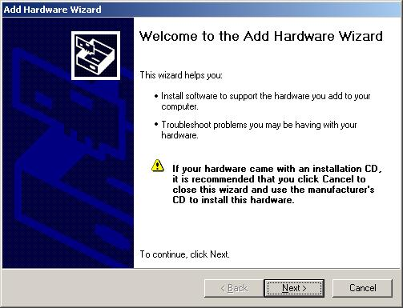
that you already have it connected
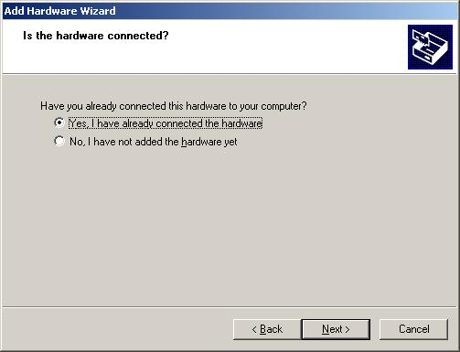
add a new hardware device
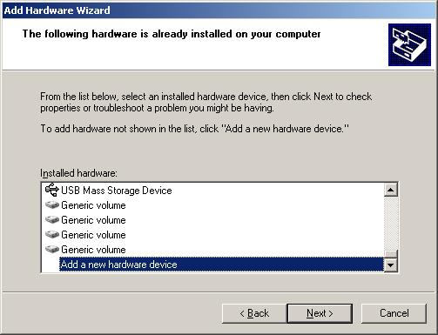
install hardware manually from a list
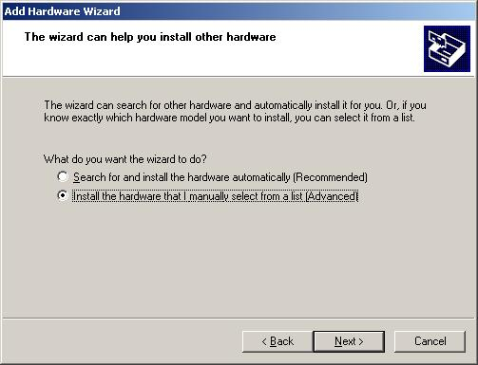

ports (COM port)
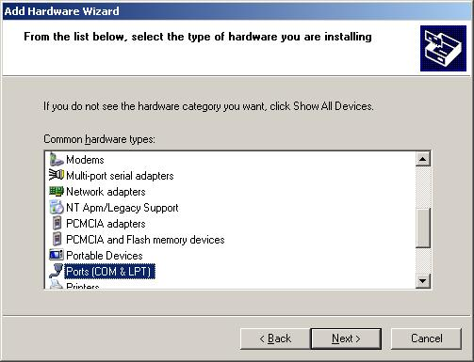

standard port types, communication port
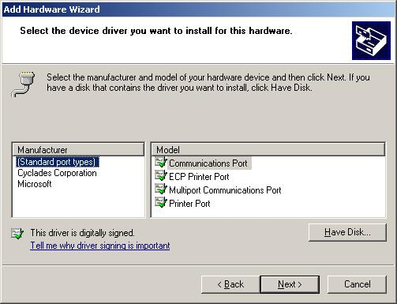
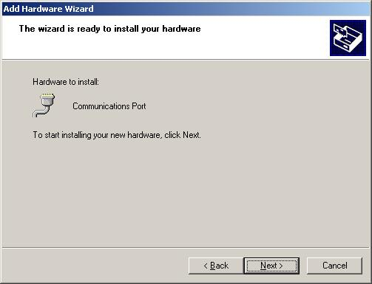
Continue to press ‘Next’ until ‘Finish’ appears. It should add without complaint.

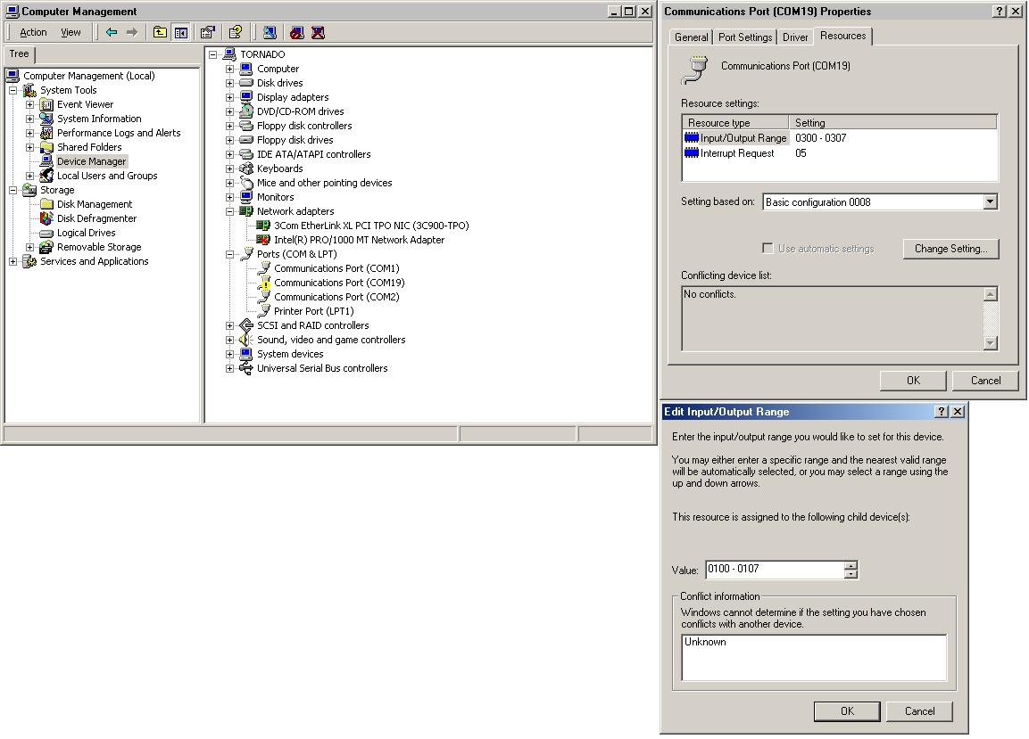
Then, go to Device Manager,
find the new COM port, which may or may not have an 'exclamation' mark next to it, and go to Properties

Go to the Resources tab
Select settings based on configuration '8' to change the resources as you wish
Select the base address and/or interrupt for the desired physical port
Click Change Settings

Make sure the base address does not conflict with other devices on your board, as Windows usually cannot automatically do this.
Windows may be able to determine if an IRQ is conflicting, but even if it is not, you should always check your BIOS to make sure that your IRQ’s are either ‘reserved’ for use of your board, or ‘set for ISA use’.

Do the same for the rest of the ports you want to add

